**National Library of Malaysia**

**1.0 Background**

The National Library of Malaysia (Malay: Perpustakaan Negara Malaysia) (PNM) is a library established under the National Library Act 1972 in Kuala Lumpur, Malaysia.

The National Library is responsible for providing a collection of knowledge at national level for the present and future generations. In its effort to strengthen the library's collection, the National Library continues to play an active role in its acquisition of library materials through enforcement of the Deposit of Library Material Act 1986, acquisition, gift and exchange.

The pride of the National Library's collection is the Malaysiana Collection. It comprises library materials published in Malaysia and overseas whose whole or larger part of the content is related to the publications date or the language used.

**2.0 Product and service**

**2.1 Library membership**

-We allowed customer register become a library membership in our library. If you are a library member you can get the new information from the library. For example, when the library purchased some new book the library member will get the info. National Library of Malaysia also allowed library member to apply a scholarship. Of course, the simplest usage is that you can borrow books from the library.

**2.2 Cataloging**

- The books in the library are arranged in an orderly manner so that users can find the books they need. They also can investigation some specific book by OPAC system (Online public access catalog system).

**2.3 Library Card**

-All library member should hold a PNM (Perpustakaan Negara Malaysia) ID card through the library security gate and access to library services and borrow books from the library. The holder is the only valid user of the PNM ID card. All Malaysians can borrow books from the library using PNM ID cards.

**2.4 Borrow and return service**

- National Library of Malaysia also allowed a user to borrow the book, magazine and newspaper form our library. Of course, you can borrow books if you are a member of the library.

**2.5 Book, Newspaper and magazine**

-This are the library’s products that allow the user to read. Of course, it also allows the user to borrow.

**3.0 Business Operation**

**3.1 Size of Business Operation**

3.1.1 Market Coverage

The market share of National Library of Malaysia reached 52% in 2014, decrease 3% in 2015 which was reaching 49%. In 2016, it reached 50% which is increased 1% compared to last year. It decreased again to 46% in 2018 which is 4% less than last year. In 2018, National Library of Malaysia has increased 2% of its market share and reached 48%.

The pie chart above shows the percentage of market share of National Library of Malaysia in 2018.

3.1.2 Annual Sales Turnover

The diagram above shows the annual sales of National Library of Malaysia.

**3.2 Customers**

3.2.1 Students

- Our major customers are the students. This is because students can get some of the latest books in any subjects here. The purposes of students borrowing books in our library may different. Some of them borrow books for examination, some of them borrow books for practising and learning.

3.2.2 Teachers

- Teachers will borrow some books for referring of their subjects. It is to help their students in learning those subjects.

3.2.3 Books lover / Intellectuals

- The National Library of Malaysia provides every kind of books for readers. It is a must visit library for books lover and intellectuals.

3.2.4 Authors / Writers

- As a authors and writers, they like to read a lot of books in order to get inspiration for writing their own books. National Library Malaysia will provide the books and the best environment for them.

**3.3 Collaboration With Other Libraries**

3.3.1 In State

- SCOM

* Sub-Committee members On Microforms (SCOM) is the relations and cooperation between the Librarians Association of Malaysia and Library Association of Singapore which has successfully established in May 1968.
* The aim of SCOM is to exchange knowledge according to the standard format which is recognized by the latest technology in order to enhance the conservation of heritage resources.

- VTLS User Group Malaysia

* The establishment of VTLS user group in Malaysia was on August 17, 1999 with 7 membership of the National Library of Malaysia, the National Productivity Centre (NPC), Universiti Putra Malaysia, Department of the Prime Minister, Ministry of International Trade and Industry (MITI), Institute of Diplomatic Training Institute and Foreign Relations (IDFR) and the Public Library in.
* The aim of VTLS user group is to get together to share experiences in dealing with VTLS software.

3.3.2 Foreign Country

- NLG-SEA

* NLG-SEA is the Heads of the National Library in Southeast Asia cooperate together to conduct collaborative project among the National Library in the region.

- CONSAL

* CONSAL is a forum among librarians from Southeast Asian countries.
* The aim of CONSAL is to build up a cooperative relationship and be able to run various projects together.

3.3.3 International

- IFLA

* IFLA is a combination of internationally Library Association.
* National Library of Malaysia became a member of this association with exchanging letters with institutions involved.

- APINESS (UNESCO)

* Asia-Pacific Information Network in Social Science (APINESS) is a program created in early 1986 by Unesco organizations for the coordination of collecting and disseminating information and activities in the field of the social sciences in Asia and the Pacific.

**4.0 Organizational Structure**

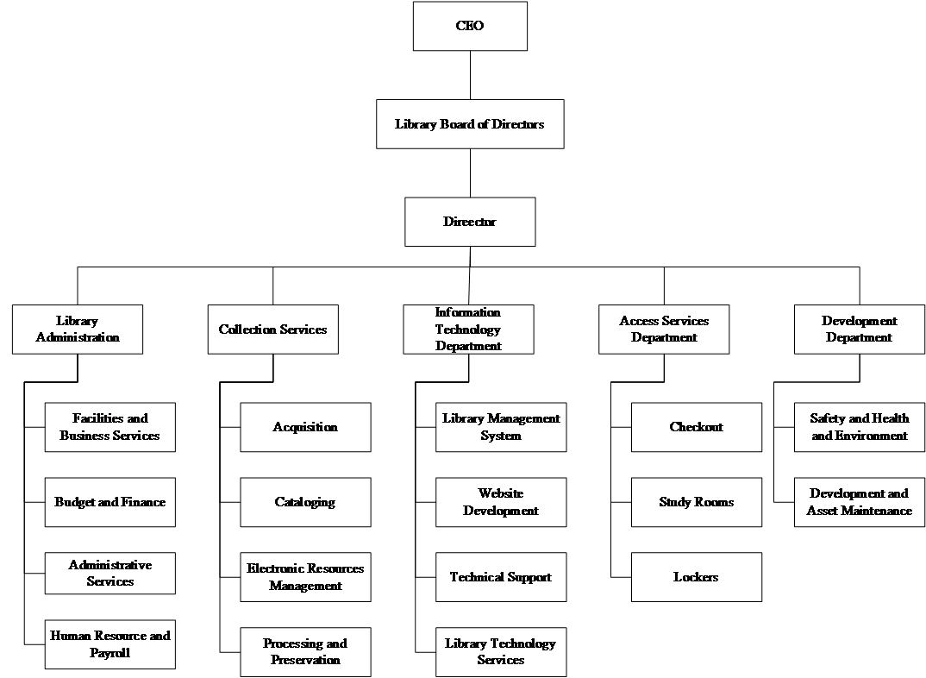

The structure chart demonstrates the organizational structure of The National Library of Malaysia.

**4.1 Functional Area**

4.1.1 Library Administration

**Handles interior and outside managerial issues**

Library administration controls everything administrative matters for the Libraries, giving administrative initiative, resource management, development, and so on. Library services and programs were all organized by library administration. Other than that, library administration controls over the budget and finance, administrative reports and other administrative needs.

4.1.2 Collection Services

**Getting, preserving, describing library materials**

Collection services is capable for getting, preserving, and describing library materials to teach and research the needs of the customers that comes to the library. Furthermore, the collection services provide the customers to access the collections of the library. For examples, journals, books, e-journals, databases and so on.

4.1.3 Information Technology Department

**Controls infrastructure and many technology services of the library**

Information technology department manages library infrastructure, technical support service for the facilities of the library, application development, and so on. Information technology department also provides technical tools like computer and printer for customers to use.

4.1.4 Access Service Department

**Providing assistance in finding, borrowing, returning and requesting the library materials for customers**

Library materials are found, borrowed, returned, and requested at the circulation desk in access service department. Access service department provides shelf maintenance, document delivery, study rooms, locker and lost and found service.

4.1.5 Development Department

**Providing maintenance and advancement for the library systems**

Development department conduct research program includes library’s facilities, equipment, designs, books, and so on. Besides that, development department checks and controls the the overall library’s quality to ensure the longevity of the library.